22. Assessment of the Octopus Stock in the Bering Sea and Aleutian Islands

Lee Cronin-Fine, Benjamin C. Williams, and Sandra Lowe and Kerim Aydin

November 2023

# Executive Summary

Through 2010, octopuses were managed as part of the Bering Sea/Aleutian Islands (BSAI) “other species” complex, along with sharks, skates, and sculpins. Historically, catches of the other species complexes were well below TAC. Due to increasing market values, retention of species within the other species complex increased. Beginning in 2011, an amendment to the BSAI fisheries management plan provided separate management for sharks, skates, sculpins, and octopus and set catch limits for each species group. Initially, catch limits for octopus were set using Tier 6 methods based on the maximum historical incidental catch rate. Since 2012, a methodology based on consumption of octopus by Pacific cod (*Gadus macrocephalus)* is used to set catch limits (see Conners *et al.* 2016 for methodological details).

This year’s assessment is an update, meaning new consumption data was provided through 2022 to determine catch limits. Alternative models/methodologies were not considered. At least nine species of octopus are found in the BSAI though in this update assessment, all octopus species are grouped into a single assemblage. The species composition of the octopus community is not well documented, but data indicate that the giant Pacific octopus (*Enteroctopus dofleini*) is the most common. Octopuses are taken as incidental catch in trawl, longline, and pot fisheries with a portion retained and sold for human consumption or bait. The BSAI trawl surveys produce highly variable biomass estimates for octopus

## Summary of Changes in Assessment Inputs

1. This assessment methodology has not changed from previous assessments, but the calculation of annual and long-term average consumption rates has been updated using 13,614 additional Pacific cod stomach samples collected from 2012-2013 and 2016-2023. The updated data set and consumption estimates were used to derive updated catch limits.

## Summary of Results

For 2024, the recommended maximum allowable ABC from the Tier 6 model is 4,560 t. Reference values for octopus are summarized in the following table, with the recommended ABC and OFL values for 2024 in bold.

|  | As estimated or *specified last* year for: | | As estimated or *recommended this* year for: | |
| --- | --- | --- | --- | --- |
| **Quantity/Status** | 2023 | 2024 | **2024** | 2025 |
|  | 6 | 6 | 6 | 6 |
| OFL (t) | 4,769 | 4,769 | **6,080** | 6,080 |
| *max*ABC (t) | 3,576 | 3,576 | 4,560 | 4,560 |
| ABC (t) | 3,576 | 3,576 | **4,560** | 4,560 |
|  | As determined *last* year for: | | As determined *this* year for: | |
| Status | 2021 | 2022 | 2022 | 2023 |
| Overfishing | No | n/a | No | n/a |

The BSAI octopus complex is not currently subject to overfishing because the 2022 catch of 251 t is smaller than the 2022 OFL of 4,769 t.



## Responses to SSC and Plan Team Comments on Assessments in General

There were no Plan Team or SSC comments specific to this assessment

## Responses to SSC and Plan Team Comments Specific to this Assessment

There were no Plan Team or SSC comments specific to this assessment

# Introduction

The full introduction can be found in the 2020 octopus assessment (Olav A. Ormseth *et al.* 2020). What follows is an abbreviation of the 2020 introduction.

Octopuses are marine mollusks in the class Cephalopoda. The cephalopods, whose name literally means head foot, have their appendages attached to the head and include octopuses, squids, and nautiluses. The octopuses (order Octopoda) have only eight appendages/arms and, unlike other cephalopods, lack shells, pens, and tentacles. There are two groups of Octopoda, the cirrate and the incirrate. The cirrate have cirri (cilia-like strands on the suckers), possess paddle-shaped fins suitable for swimming in their deep ocean pelagic and epibenthic habitats (Boyle and Rodhouse 2005), and are much less common than the incirrate which contain the more traditional forms of octopus. Octopuses are found in every ocean in the world and range in size from less than 20 cm to over 3 m (total length); the latter is a record held by *Enteroctopus dofleini* (Wülker 1910). The most common octopus species in the survey is *E. dofleini* but there are at least seven other species found in the Bering sea which include *Sasakiopus salebrosus*, *Benthoctopus leioderma*, *Benthoctopus oregonensis*, *Graneledone boreopacifica*, *Opisthoteuthis californiana*, *Japetella diaphana* and *Vampyroteuthis infernalis* (Tables 22-1,-2,-3). These eight species represent seven genera and can be found from less than 10-m to greater than 1500-m depth. All but one, *J. diaphana*, are benthic octopuses. The mesopelagic *V. infernalis* is a cephalopod that shares similarities with both octopuses and squids, but is included in the octopus assessment. The state of knowledge of octopuses in the BSAI, including the true species composition, is very limited.

# Fishery

A full description of the fishery’s history can be found in the 2020 octopus assessment (Olav A. Ormseth *et al.* 2020). What follows are any recent significant changes to the fishery or management measures.

### Directed Fishery

There is no federally-managed directed fishery for octopus in the BSAI. The State of Alaska allows for directed (under a special commissioner’s permit) and incidental catch of octopus in state waters. Since 2006, the number of permits for direct octopus fishing has been declining. The catch of octopus in state waters has been predominately incidental (Bevaart 2022; Nichols and Shaishnikoff 2022).

### Incidental Catch

Octopus are caught incidentally throughout the BSAI in both state and federally-managed bottom trawl, longline, and pot fisheries. Since 2003, the total octopus catch in federal waters (including discards) has been estimated using the National Marine Fisheries Service (NMFS) Alaska Regional Office catch accounting system. Total incidental catch range from approximately 200-700 t with high year-to year variability (Table 22-4). In 2011, the catch for octopus in BSAI (577 t) exceeded the OFL (528 t) resulting in NMFS closing the directed fishing for Pacific cod with pot gear in the BSAI on October 21, 2011. The following year, an alternative Tier 6 method was introduced. Since then, all catches have been nearly an order of magnitude below the recommended ABC (Table 22-4).

# Data

## Fishery

See Table 22-4 and Figure 22-2 for a time series of the total catch from 1997 to 2023. The 2023 catch data are incomplete. They were updated through September 16, 2023. The tier 6 methodology used for the BSAI octopus assessment does not use fishery catch when determining catch limits.

## Survey

### Biomass Estimates from Trawl Surveys

Biomass estimates for the octopus species complex based on the bottom trawl surveys are shown in Tables 22-1,-2 and -3. EBS shelf surveys are annual while AI surveys are on even years, except for 2020 when both survey were canceled due to the COVID-19 pandemic. EBS slope surveys were conducted irregularly and the last survey was in 2016. Biomass estimates in the EBS and AI show high year-to-year variability (Figure 22-1). There is a large sampling variance associated with estimates from the shelf surveys because a large number of tows do not capture octopuses. It is impossible to determine how much of the year–to-year variability in the estimated biomass reflects true variation in abundance or is a result of sampling variation. For example, the 1997 biomass estimate from the shelf survey (254 t) approximately equaled the estimated commercial catch (249 t). This suggests that the 1997 biomass estimate was unreasonably low. In 2023, the EBS shelf biomass estimate decreased by 48% from 2022 biomass estimate of 4,941 t to 2,557 t. The 2023 EBS shelf biomass estimate is also 39% lower than the long-term average biomass from the EBS shelf (4,189 t) and is the lowest biomass estimate since 2014. The tier 6 methodology used for the BSAI octopus assessment does not use survey biomass estimates when determining catch limits.

## Other Data

The BSAI octopus assessment relies on diet data from their main predator in the BSAI, Pacific cod. Since Pacific cod is an important commercial species, the Alaska Fisheries Science Center (AFSC) food habits group collects a large number of Pacific cod stomachs for diet analysis (Table 22-5). Since 2016, when the catch limits were last updated, a total of 13,614 stomachs from 2012-2013 and 2016-2023 have been added to the data set.

# Analytical approach

## General Model Structure

The available data for octopus in the BSAI do not support quantitative catch-at-age modeling for either individual species of octopus or for the multi-species complex. There are also no reliable biomass estimates unavailable for Tier 5 methods. Therefore, we continue to use the alternative Tier 6 method, based on a predation-based estimate of total natural mortality (*N*) (Conners *et al.* 2011).

The 2011 BSAI octopus assessment methodology uses the underlying model from Tier 5, where MSY is obtained at ½ the total natural mortality (in tons). For Tier 5 stocks, the total natural mortality is usually estimated as the product of biomass (*B*) and an instantaneous mortality rate (*M*), *N=MB*. We use the letter *N* for the total natural mortality in tons to distinguish it from the *M* (continuous individual mortality rate) that is used widely in other stock assessment models. This method uses data from the AFSC’s food habits database to estimate the total amount of octopus consumed by their main predator in the BSAI: Pacific cod. The amount of octopus consumed by Pacific cod is a conservative estimate of the total natural mortality *N* for octopus, since it does not include mortality from other predators (i.e., marine mammals) or non-predation mortality. It is important to note that this methodology calculates a single reference point that is averaged over multiple years in order to avoid assuming a population increase when it is just an increase in predation. Therefore, the reference point should be updated every couple of years instead of every year. This analysis was first performed in 2011 (Conners *et al.* 2011) and last updated in the 2016 assessment (Conners *et al.* 2016).

## Parameter Estimates

*Total Natural Mortality (N)*  
*N* was estimated using previously defined methods. See “General Model Structure” for a description and the 2016 assessment (Conners *et al.* 2016) for more details.

# Results

## Harvest Recommendations

*Amendment 56 Reference Points/ Specification of OFL and Maximum Permissible ABC*  
Since 2011, the Plan Team and SSC have used an alternative method based on biological reference points derived from consumption estimates for Pacific cod. This estimate of natural mortality (*N*) can then be combined with the general logistic fisheries model that forms the basis of Tier 5 assessments (Alverson and Pereyra 1969; Francis 1974) (Alverson and Petreyra 1969, Francis 1974) to set OFL = *N* and ABC = 0.75 * OFL. **When this method is used, the resulting catch limits are OFL = 6,080 t and ABC = 4,560 t which are our recommended 2024 and 2025 ABCs and OFLs.**

We do not recommend a directed fishery for octopus in federal waters at this time, because data are insufficient for adequate management. We anticipate that octopus catch in federal waters of the BSAI will continue to be largely incidental catch in existing groundfish fisheries.

*Status Determination*  
The BSAI octopus complex is not subject to overfishing because the 2022 catch,the most recent completed year, of 251 t is much smaller than the 2022 OFL of 4,769 t (Figure 22-2).

# Ecosystem Considerations

A full description of the ecosystem considerarions can be found in the 2020 octopus assessment (Olav A. Ormseth *et al.* 2020). What follows is an abbreviation from the 2020 octopus assessment.

Little is known about the role of octopus in North Pacific ecosystems. Food habits data and ecosystem modeling of the Bering Sea and AI (Livingston *et al.* 2003; Aydin *et al.* 2008) indicate that octopus diets are dominated by other benthic invertebrates such as mollusks, hermit crabs, starfish, and snow crabs. Octopus mortality Sea comes primarily from Pacific cod, resident seals, walrus, bearded seals, and sculpins. The majority of the octopus incidental catch is taken in pot gear fished for Pacific cod. To avoid gear conflicts with trawlers, cod pots are usually deployed inside of no-trawl zones or in rocky areas unsuitable for trawling. The low retention rate of octopus in the BSAI, and the high survival rate of discarded octopus suggest that effects on the octopus population is minor.

# Data Gaps and Research Priorities

A full description of the data gaps and research priorities can be found in the 2020 octopus assessment (Olav A. Ormseth *et al.* 2020). What follows is an abbreviation from the 2020 octopus assessment.

Though there have been efforts to improve the collection of basic octopus data, there is still alot that is unknown. The areas of needed/on going research include improving aging methods, determining octopus species composition in catch and survey, determining octopus distribution especially when reproducing and producing reliable fisheries independent biomass estimates.

# References

Alverson, D.L. and Pereyra, W.T. (1969) Demersal fish explorations in the northeastern pacific ocean – an evaluation of exploratory fishing methods and analytical approaches to stock size and yield forecasts. *Journal of the Fisheries Research Board of Canada* 26, 1985–2001.

Aydin, K., Gaichas, S., Ortiz, I., Kinzey, D. and Friday, N. (2008) A comparison of the Bering Sea, Gulf of Alaska, and Aleutian Islands large marine ecosystems through food web modeling. NOAA Tech Memo.

Bevaart, K. (2022) Annual management report for shellfish fisheries in the Kodiak, Chignik, and South Peninsula Districts, 2021. Alaska Department of Fish; Game, Fishery Management Report No. 22-18, Anchorage.

Boyle, P. and Rodhouse, P. (2005) *Cephalopods: Ecology and Fisheries*. Blackwell Publishing, Oxford, UK.

Conners, M.E., Aydin, K.Y. and Conrath, C.L. (2016) Assessment of the octopus stock complex in the bering sea and aleutian islands. In: *Stock assessment and fishery evaluation report for the groundfish resources of the Bering Sea and Aleutian Islands regions*. North Pacific Fishery Management Council, Anchorage, AK.

Conners, M.E., Conrath, C.L. and Aydin, K. (2011) Assessment of the octopus stock complex in the bering sea and aleutian islands. In: *Stock assessment and fishery evaluation report for the groundfish resources of the Bering Sea and Aleutian Islands regions*. North Pacific Fishery Management Council, Anchorage, AK.

Francis, R.C. (1974) Relationship of fishing mortality to natural mortality at the level of maximum sustainable yield under the logistic stock production model. *Journal of the Fisheries Research Board of Canada* 31, 1539–1542.

Livingston, P.L., Aydin, K.Y., Boldt, J., Gaichas, S., Ianelli, J., Jurado-Molina, J. and Ortiz, I. (2003) Ecosystem assessment of the bering sea/aleutian islands and gulf of alaska management regions. In: *Stock assessment and fishery evaluation report for the groundfish resources or the Bering Sea/Aleutian Islands regions*. North Pacific Fishery Management Council, Anchorage, AK.

Nichols, E. and Shaishnikoff, J. (2022) Annual management report for shellfish fisheries of the Bering Sea/Aleutian Islands Management Area, 2021/22. Alaska Department of Fish; Game, Fishery Management Report No. 22-28, Anchorage.

Olav A. Ormseth, Elizabeth M. Conners, Aydin, K. and Conrath, C.L. (2020) Assessment of the octopus stock complex in the bering sea and aleutian islands. In: *Stock assessment and fishery evaluation report for the groundfish resources of the Bering Sea and Aleutian Islands regions*. North Pacific Fishery Management Council, Anchorage, AK.

Wülker, G. (1910) Uber Japanische cephalopoden: Beitrage zur kenntnis der systematik und anatomie der dibranchiaten. *Abhandlungen der Mathematisch-Physikalischen Classe der Koniglich Bayerischen Akademie der Wissenschaften* 1, 1–77.

# Tables

Table 22-1. Survey biomass estimates (t) for octopus species from the Aleutian Islands. CV is coefficient of variation. “octopus unID” is octopus unidentified.

|  | *B. leioderma* | | *E. dofleini* | | *J. diaphana* | | *Benthoctopus sp* | | *S. salebrosus* | | *B. oregonensis* | | octopus unid. | | Total | |
| --- | --- | --- | --- | --- | --- | --- | --- | --- | --- | --- | --- | --- | --- | --- | --- | --- |
| **Year** | **Biomass** | **CV** | **Biomass** | **CV** | **Biomass** | **CV** | **Biomass** | **CV** | **Biomass** | **CV** | **Biomass** | **CV** | **Biomass** | **CV** | **Biomass** | **CV** |
| 1991 | 57 | 50 | 57 | 45 |  |  |  |  |  |  |  |  | 1,046 | 22 | 1,159 | 20 |
| 1994 |  |  | 1,186 | 27 |  |  |  |  |  |  |  |  | 541 | 21 | 1,727 | 19 |
| 1997 |  |  | 451 | 50 |  |  |  |  |  |  |  |  | 769 | 27 | 1,219 | 25 |
| 2000 |  |  | 444 | 45 |  |  |  |  |  |  |  |  | 345 | 38 | 788 | 30 |
| 2002 | 7 | 50 | 623 | 25 |  |  |  |  |  |  |  |  | 762 | 48 | 1,393 | 28 |
| 2004 |  |  | 4,076 | 35 | 0 | 100 | 0 | 100 |  |  |  |  | 19 | 99 | 4,095 | 34 |
| 2006 | 1 | 100 | 3,037 | 17 |  |  |  |  |  |  |  |  | 24 | 71 | 3,062 | 17 |
| 2010 |  |  | 3,074 | 30 |  |  |  |  |  |  |  |  | 1 | 55 | 3,075 | 30 |
| 2012 | 31 | 63 | 2,739 | 42 |  |  |  |  | 1 | 80 |  |  | 8 | 100 | 2,779 | 42 |
| 2014 | 5 | 71 | 2,762 | 20 |  |  |  |  | 0 | 100 |  |  | 78 | 22 | 2,845 | 20 |
| 2016 | 0 | 94 | 3,752 | 24 |  |  | 4 | 100 | 1 | 100 | 1 | 100 | 75 | 100 | 3,833 | 24 |
| 2018 | 1 | 71 | 2,231 | 40 | 4 | 100 |  |  | 0 | 100 |  |  | 38 | 100 | 2,274 | 39 |
| 2022 | 0 | 100 | 1,505 | 23 |  |  |  |  |  |  |  |  | 0 | 100 | 1,505 | 23 |

Table 22-2. Survey biomass estimates (t) for octopus species from the EBS shelf. CV is coefficient of variation. “octopus unID” is octopus unidentified.

|  | *B. leioderma* | | *E. dofleini* | | *Benthoctopus sp* | | *S. salebrosus* | | *B. oregonensis* | | octopus unid. | | Total | |
| --- | --- | --- | --- | --- | --- | --- | --- | --- | --- | --- | --- | --- | --- | --- |
| **Year** | **Biomass** | **CV** | **Biomass** | **CV** | **Biomass** | **CV** | **Biomass** | **CV** | **Biomass** | **CV** | **Biomass** | **CV** | **Biomass** | **CV** |
| 1987 | 540 | 56 | 4,181 | 88 |  |  |  |  |  |  | 3,109 | 54 | 7,829 | 52 |
| 1988 |  |  | 5,921 | 42 |  |  |  |  |  |  | 3,944 | 37 | 9,865 | 29 |
| 1989 |  |  |  |  |  |  |  |  |  |  | 4,895 | 33 | 4,895 | 33 |
| 1990 |  |  |  |  |  |  |  |  |  |  | 11,589 | 48 | 11,589 | 48 |
| 1991 |  |  |  |  |  |  |  |  |  |  | 8,070 | 34 | 8,070 | 34 |
| 1992 |  |  |  |  |  |  |  |  |  |  | 5,607 | 42 | 5,607 | 42 |
| 1993 |  |  |  |  |  |  |  |  |  |  | 1,582 | 34 | 1,582 | 34 |
| 1994 |  |  |  |  |  |  |  |  |  |  | 2,480 | 39 | 2,480 | 39 |
| 1995 |  |  |  |  |  |  |  |  |  |  | 2,934 | 59 | 2,934 | 59 |
| 1996 |  |  |  |  |  |  |  |  |  |  | 1,809 | 68 | 1,809 | 68 |
| 1997 |  |  |  |  |  |  |  |  |  |  | 254 | 40 | 254 | 40 |
| 1998 |  |  | 548 | 100 |  |  |  |  |  |  | 738 | 49 | 1,285 | 51 |
| 1999 |  |  |  |  |  |  |  |  |  |  | 834 | 52 | 834 | 52 |
| 2000 |  |  | 465 | 100 |  |  |  |  |  |  | 1,563 | 44 | 2,028 | 41 |
| 2001 |  |  | 100 | 69 |  |  |  |  |  |  | 5,785 | 32 | 5,885 | 32 |
| 2002 |  |  | 641 | 95 |  |  |  |  |  |  | 1,860 | 49 | 2,502 | 44 |
| 2003 | 44 | 83 | 5,163 | 65 |  |  |  |  |  |  | 3,046 | 59 | 8,254 | 46 |
| 2004 |  |  | 4,919 | 31 |  |  |  |  |  |  | 35 | 86 | 4,954 | 31 |
| 2005 | 516 | 59 | 9,558 | 30 |  |  |  |  |  |  | 142 | 67 | 10,215 | 28 |
| 2006 | 328 | 45 | 1,570 | 40 | 6 | 100 |  |  |  |  |  |  | 1,904 | 34 |
| 2007 | 66 | 75 | 2,113 | 31 |  |  |  |  |  |  | 97 | 55 | 2,276 | 29 |
| 2008 | 132 | 71 | 1,013 | 48 | 25 | 100 |  |  |  |  | 0 | 100 | 1,170 | 42 |
| 2009 | 186 | 56 | 819 | 64 | 8 | 94 |  |  |  |  | 0 | 100 | 1,013 | 53 |
| 2010 | 27 | 83 | 642 | 59 |  |  | 142 | 58 |  |  |  |  | 811 | 48 |
| 2011 | 249 | 39 | 2,833 | 33 |  |  |  |  |  |  | 458 | 100 | 3,541 | 30 |
| 2012 | 478 | 37 | 2,088 | 39 |  |  |  |  |  |  | 0 | 100 | 2,566 | 32 |
| 2013 | 97 | 50 | 1,657 | 53 | 1 | 100 |  |  | 13 | 100 | 44 | 91 | 1,813 | 49 |
| 2014 | 157 | 60 | 2,078 | 54 |  |  | 4 | 100 | 93 | 100 | 2 | 80 | 2,334 | 49 |
| 2015 | 113 | 63 | 5,223 | 31 |  |  |  |  |  |  | 2 | 77 | 5,338 | 30 |
| 2016 | 327 | 35 | 6,927 | 47 |  |  | 188 | 46 |  |  | 1 | 100 | 7,442 | 44 |
| 2017 | 1,578 | 27 | 1,777 | 44 | 7 | 84 |  |  |  |  | 655 | 64 | 4,017 | 24 |
| 2018 | 603 | 37 | 4,648 | 29 |  |  |  |  |  |  |  |  | 5,251 | 26 |
| 2019 | 353 | 41 | 5,538 | 26 |  |  |  |  |  |  | 26 | 40 | 5,916 | 24 |
| 2021 | 27 | 70 | 5,026 | 31 |  |  |  |  | 0 | 100 | 1 | 68 | 5,054 | 31 |
| 2022 | 243 | 91 | 4,628 | 28 | 24 | 85 |  |  | 43 | 64 | 3 | 90 | 4,941 | 26 |
| 2023 | 6 | 92 | 2,518 | 32 | 15 | 72 |  |  | 7 | 61 | 11 | 73 | 2,557 | 32 |

Table 22-3. Survey biomass estimates (t) for octopus species from the EBS slope. CV is coefficient of variation. “octopus unID” is octopus unidentified.

|  | *B. leioderma* | | *G. boreopacifica* | | *E. dofleini* | | *Benthoctopus sp* | | | | *J. diaphana* | | |
| --- | --- | --- | --- | --- | --- | --- | --- | --- | --- | --- | --- | --- | --- |
| **Year** | **Biomass** | **CV** | **Biomass** | **CV** | **Biomass** | **CV** | **Biomass** | | **CV** | | **Biomass** | **CV** | |
| 2002 | 149 | 28 | 141 | 14 | 410 | 39 | 236 | | 20 | |  |  | |
| 2004 | 291 | 14 | 245 | 39 | 993 | 24 | 119 | | 38 | | 4 | 44 | |
| 2008 | 151 | 20 | 81 | 41 | 336 | 33 | 0 | | 100 | | 10 | 31 | |
| 2010 | 87 | 21 | 96 | 46 | 216 | 33 | 77 | | 22 | | 1 | 100 | |
| 2012 | 146 | 32 | 248 | 27 | 647 | 43 |  | |  | | 5 | 61 | |
| 2016 | 133 | 20 | 143 | 16 | 566 | 31 |  | |  | | 9 | 50 | |
|  | *S. salebrosus* | | *B. oregonensis* | | *O. californiana* | | | octopus unid. | | | Total | |
| **Year** | **Biomass** | **CV** | **Biomass** | **CV** | **Biomass** | **CV** | | **Biomass** | | **CV** | **Biomass** | **CV** |
| 2002 |  |  |  |  |  |  | | 34 | | 49 | 971 | 18 |
| 2004 | 72 | 14 |  |  |  |  | | 256 | | 38 | 1,980 | 14 |
| 2008 | 23 | 16 | 27 | 40 |  |  | | 152 | | 32 | 781 | 17 |
| 2010 | 32 | 17 | 28 | 99 | 15 | 100 | | 70 | | 24 | 621 | 15 |
| 2012 | 28 | 16 |  |  |  |  | | 343 | | 22 | 1,419 | 21 |
| 2016 | 51 | 18 | 151 | 27 |  |  | | 1,211 | | 19 | 2,263 | 13 |

Table 22-4. Estimated catch (t) of all octopus species from 1997-2023 in the Bering Sea and Aleutian Islands, by target fishery. Data reflect catch posted through September 16, 2023 (sourced September 29, 2023 from the NMFS Alaska Regional Office using the AKFIN database (http://www.akfin.org)). Catch is divided into three groups based on the target fishery; Pacific cod (typically highest octopus catch), all species of flatfish and all other target fisheries combined. Pacific halibut are included in the 'other' category. Octopus did not have their own catch limits until 2011. An alternative Tier 6 method was adopted in 2012.

|  | **Target Fishery** | | | | |  | | | |
| --- | --- | --- | --- | --- | --- | --- | --- | --- | --- |
| **Year** | **P.cod** | **Flatfish** | **Other** | **Total** | **Retained** | **OFL** | **ABC** | **TAC** | **Catch/ABC** |
| 1997 | 160 | 86 | 3 | 249 |  |  |  |  |  |
| 1998 | 168 | 13 | 9 | 190 |  |  |  |  |  |
| 1999 | 310 | 14 | 2 | 326 |  |  |  |  |  |
| 2000 | 359 | 57 | 3 | 419 |  |  |  |  |  |
| 2001 | 211 | 9 | 7 | 227 |  |  |  |  |  |
| 2002 | 334 | 21 | 19 | 374 |  |  |  |  |  |
| 2003 | 224 | 32 | 21 | 277 | 31% |  |  |  |  |
| 2004 | 278 | 44 | 246 | 569 | 55% |  |  |  |  |
| 2005 | 311 | 17 | 10 | 339 | 64% |  |  |  |  |
| 2006 | 331 | 5 | 14 | 350 | 55% |  |  |  |  |
| 2007 | 156 | 7 | 9 | 171 | 41% |  |  |  |  |
| 2008 | 196 | 11 | 8 | 215 | 36% |  |  |  |  |
| 2009 | 58 | 10 | 6 | 73 | 22% |  |  |  |  |
| 2010 | 168 | 12 | 5 | 185 | 29% |  |  |  |  |
| 2011 | 555 | 9 | 14 | 577 | 6% | 528 | 396 | 150 | 146% |
| 2012 | 126 | 4 | 8 | 137 | 17% | 4,769 | 3,576 | 900 | 4% |
| 2013 | 214 | 2 | 4 | 220 | 22% | 4,769 | 3,576 | 500 | 6% |
| 2014 | 406 | 5 | 18 | 429 | 20% | 4,769 | 3,576 | 225 | 12% |
| 2015 | 412 | 6 | 24 | 441 | 18% | 4,769 | 3,576 | 400 | 12% |
| 2016 | 554 | 5 | 34 | 593 | 16% | 4,769 | 3,576 | 400 | 17% |
| 2017 | 264 | 4 | 13 | 282 | 31% | 4,769 | 3,576 | 400 | 8% |
| 2018 | 262 | 4 | 23 | 290 | 59% | 4,769 | 3,576 | 250 | 8% |
| 2019 | 238 | 13 | 17 | 268 | 48% | 4,769 | 3,576 | 400 | 7% |
| 2020 | 672 | 3 | 16 | 691 | 21% | 4,769 | 3,576 | 275 | 19% |
| 2021 | 154 | 8 | 8 | 170 | 13% | 4,769 | 3,576 | 700 | 5% |
| 2022 | 222 | 8 | 21 | 251 | 29% | 4,769 | 3,576 | 700 | 7% |
| 2023* | 81 | 5 | 35 | 120 | 49% | 4,769 | 3,576 | 400 | 3% |
| *2023 catch as of September 16, 2023 , sourced September 29, 2023 from the NMFS Alaska Regional Office using the AKFIN database (http://www.akfin.org). | | | | | | | | | |

Table 22-5. Number of Pacific cod stomach samples, from 1984-2023, analyzed for octopus consumption estimates. A total of 52,843 stomachs were analyzed.

| **Year** | **# of Samples** |
| --- | --- |
| 1984 | 581 |
| 1985 | 793 |
| 1986 | 1,351 |
| 1987 | 790 |
| 1988 | 573 |
| 1989 | 1,678 |
| 1990 | 1,157 |
| 1991 | 1,597 |
| 1992 | 1,903 |
| 1993 | 2,317 |
| 1994 | 2,397 |
| 1995 | 2,420 |
| 1996 | 1,336 |
| 1997 | 1,165 |
| 1998 | 1,272 |
| 1999 | 1,313 |
| 2000 | 1,405 |
| 2001 | 1,428 |
| 2002 | 1,333 |
| 2003 | 1,796 |
| 2004 | 0 |
| 2005 | 449 |
| 2006 | 705 |
| 2007 | 583 |
| 2008 | 1,208 |
| 2009 | 1,345 |
| 2010 | 1,198 |
| 2011 | 1,550 |
| 2012 | 1,838 |
| 2013 | 1,657 |
| 2014 | 1,644 |
| 2015 | 1,942 |
| 2016 | 1,954 |
| 2017 | 1,611 |
| 2018 | 1,619 |
| 2019 | 1,246 |
| 2020 | 0 |
| 2021 | 1,565 |
| 2022 | 985 |
| 2023 | 1,139 |

# Figures

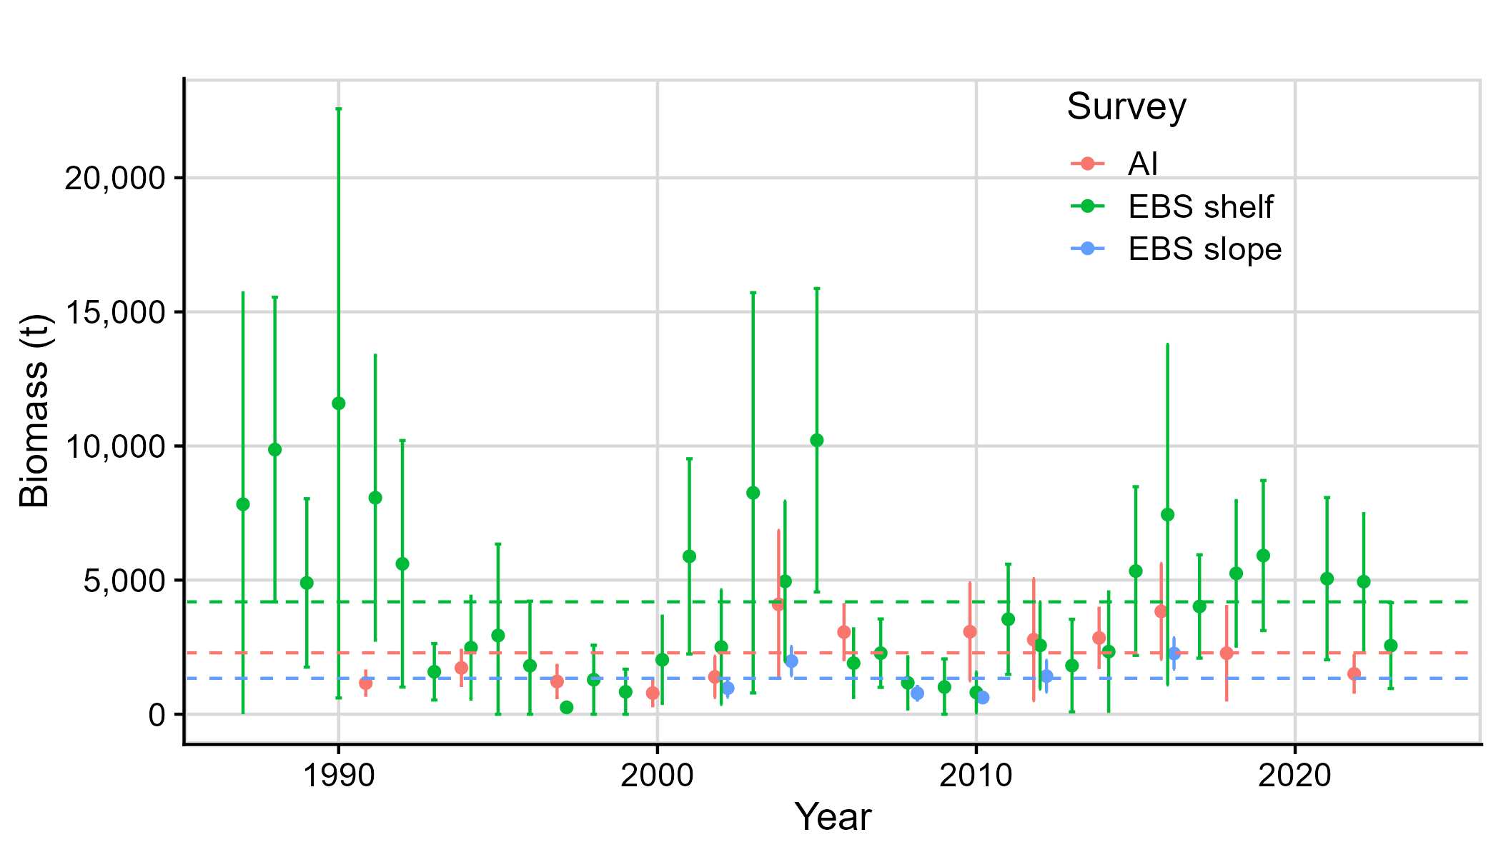

Figure 22-1. Octopus biomass estimates from the EBS shelf (1987-2023), EBS slope (2002-2016) and AI (1991-2002) surveys. The horizontal dashed lines represent the long-term average biomass for the survey with the same color. The long-term average for the Aleutian Islands is 2,289 t, the EBS shelf is 4,189 t and the EBS slope is 1,339 t.

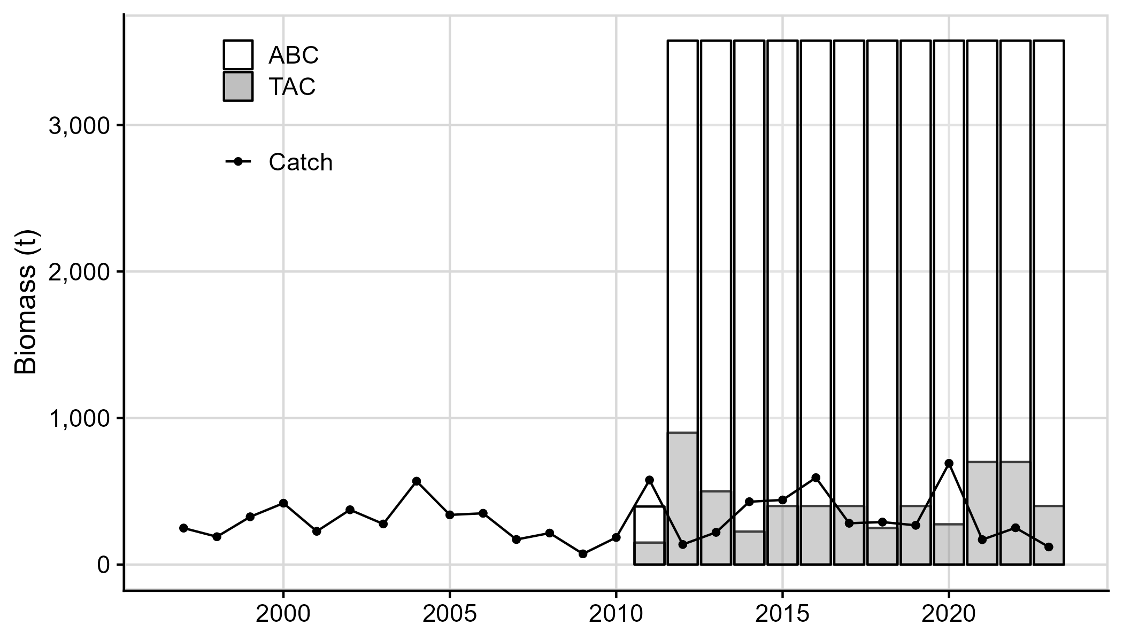

Figure 22-2. Octopus catch (retained and discarded), ABC and TAC from 1997-2023. Data reflect catch posted through September 16, 2023 (sourced September 29, 2023 from the NMFS Alaska Regional Office using the AKFIN database (<http://www.akfin.org>)).